Name: Adnan Qureshi
Roll No: 25DCO09
Class: TE CO1 Batch 3

Practical 1 - Installation and Configuration of Linux Environment
1. Aim:-
To install and configure a Linux operating system (Ubuntu) using Oracle VirtualBox on a Windows/Mac host machine, and to understand the basic setup of a virtualized Linux environment.
2. Requirements:-
Hardware:
- A computer system with minimum 4 GB RAM (8 GB recommended)
- At least 25 GB of free hard disk space
- A processor that supports virtualization (Intel VT-x / AMD-V)
Software:
- Oracle VirtualBox (latest version)
- Ubuntu Desktop ISO file (latest LTS version)
- Host operating system (Windows/macOS/Linux)
3. Theory:-
Linux is a free and open-source operating system based on the Linux kernel, originally developed by Linus Torvalds in 1991. It is widely used because of its stability, security, and flexibility, and it powers everything from personal computers to servers and embedded systems. Ubuntu is one of the most popular Linux distributions, known for its user-friendly interface and strong community support, making it a good choice for beginners as well as professionals.
Oracle VirtualBox is a free and open-source virtualization software that allows a user to run one operating system inside another without affecting the host system. By creating a virtual machine (VM), VirtualBox allocates a portion of the host's hardware resources (RAM, CPU, storage) to the guest OS, in this case Ubuntu, allowing it to run as if it were installed on a separate physical computer. This approach is safe and convenient for learning Linux without altering the existing system setup.
4. Procedure:-
- Download Oracle VirtualBox from the official website and install it on the host machine.
- Download the Ubuntu Desktop ISO file from the official Ubuntu website.
- Open VirtualBox and click on “New” to create a new virtual machine.
- Enter a name for the VM, select the type as “Linux” and version as “Ubuntu (64-bit)”.
- Allocate the required RAM (minimum 2 GB recommended) to the virtual machine.
- Create a virtual hard disk and allocate sufficient storage space (minimum 20 GB recommended).
- Start the virtual machine and select the downloaded Ubuntu ISO file as the boot disk.
- Follow the on-screen instructions to install Ubuntu: select language, keyboard layout, installation type, and create a username/password.
- Wait for the installation process to complete and restart the virtual machine.
- Remove the ISO file from the virtual drive and boot into the newly installed Ubuntu system.
- Verify the installation by checking the Ubuntu version and exploring the desktop environment.

5. Output of Execution of all with Screenshots:-
1. Download and install Oracle VirtualBox:-
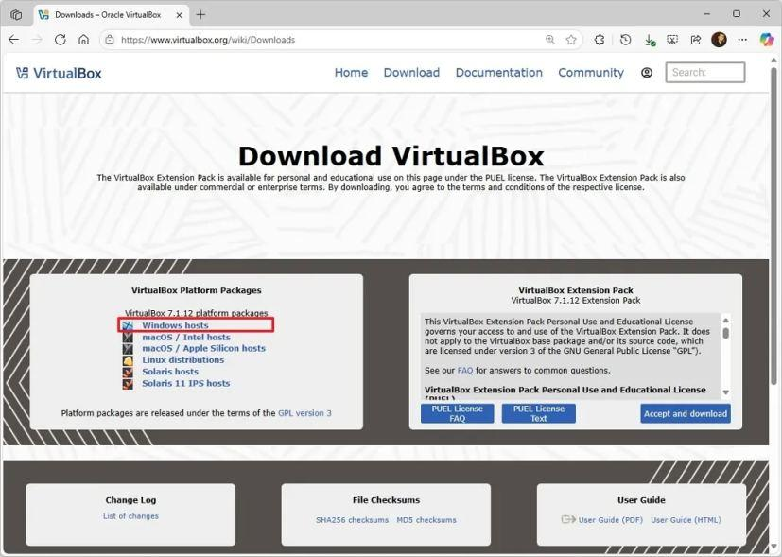
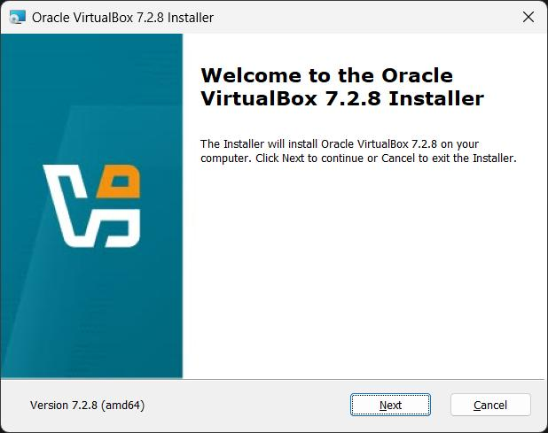
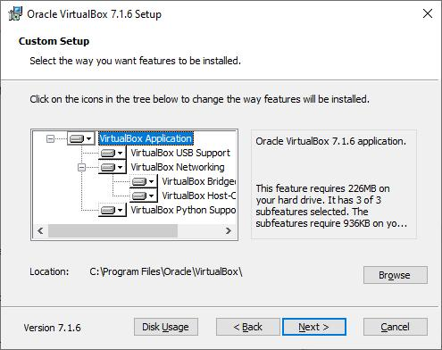
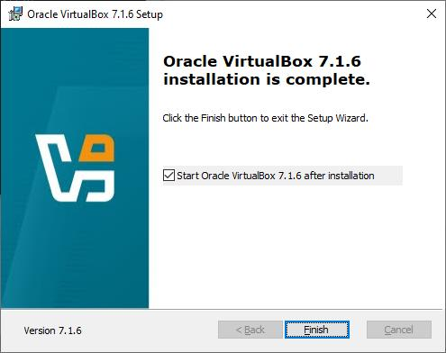

2. Create a new Virtual Machine:-
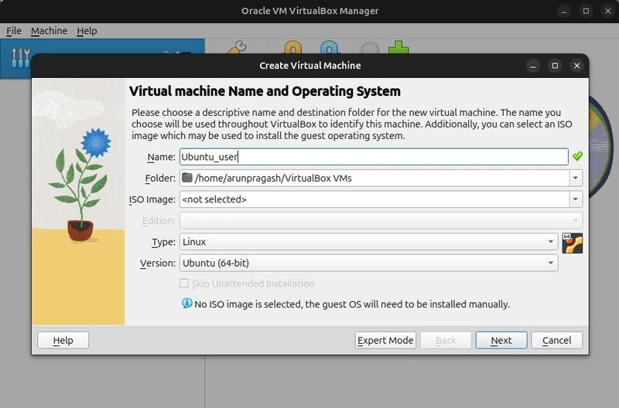
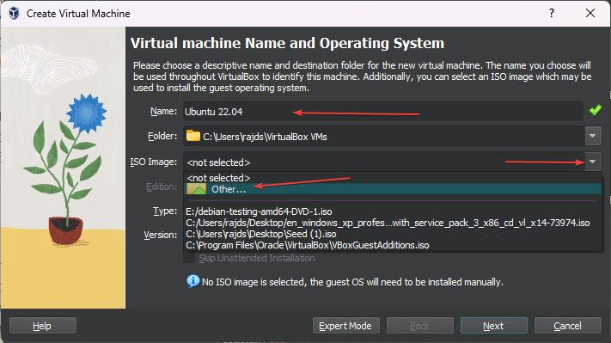
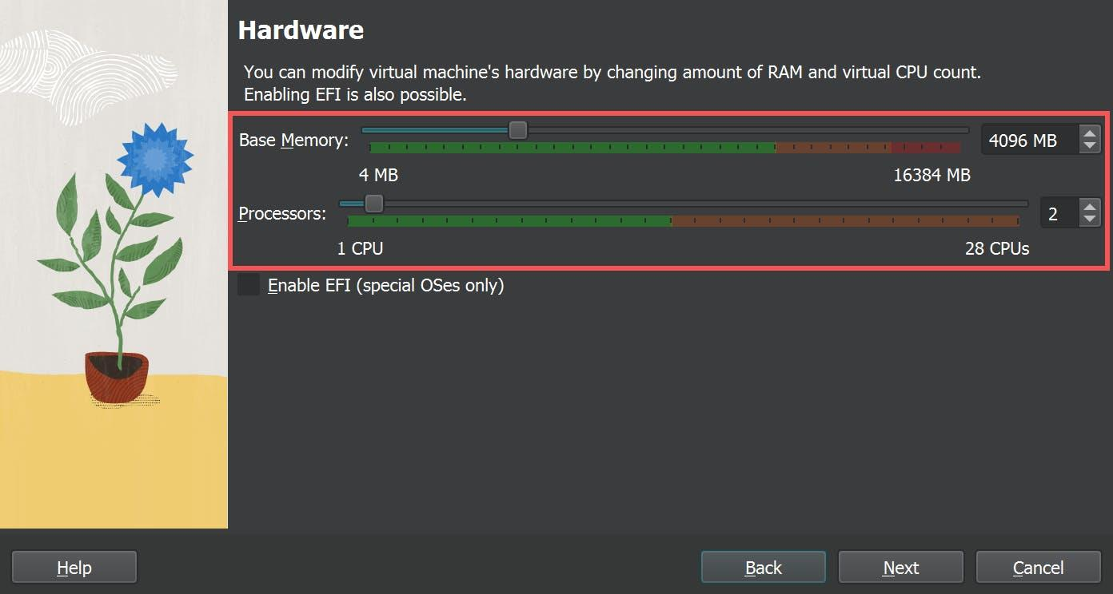
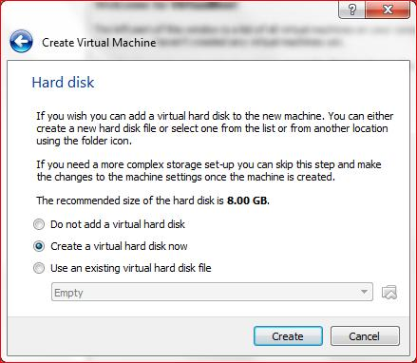

3. Start the Linux installation:-
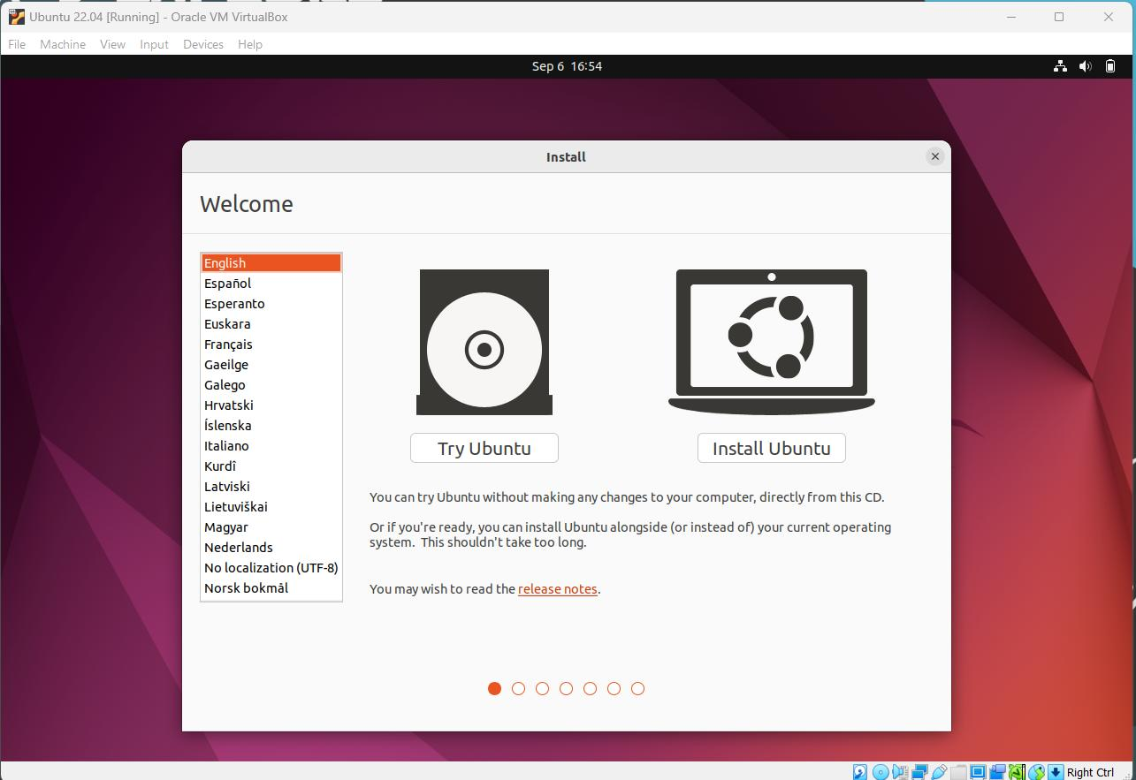
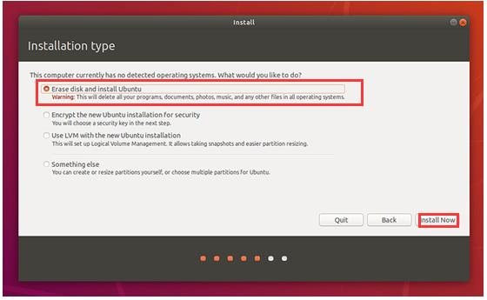
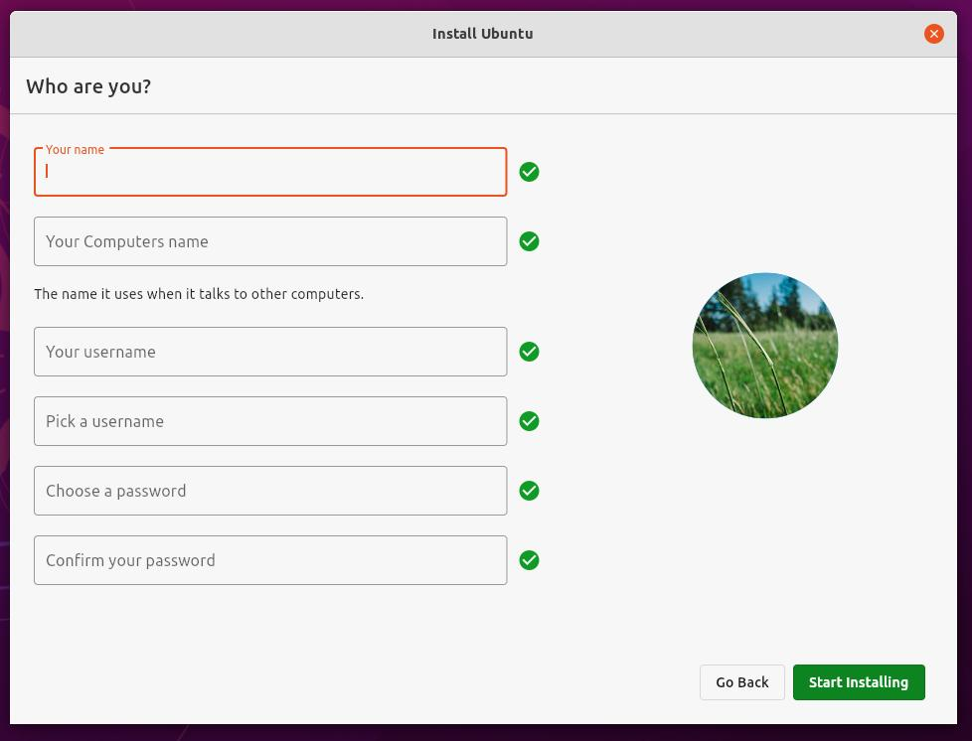
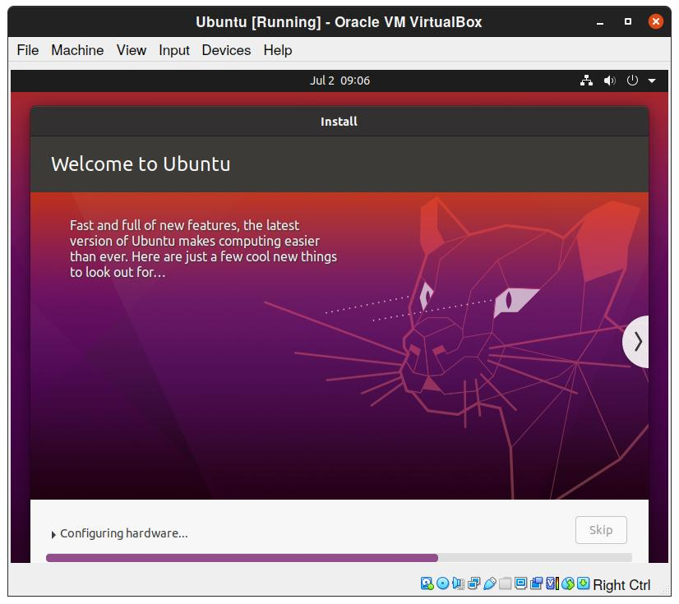

6. Error Handling / Troubleshooting:-
- Ubuntu ISO not booting: The virtual machine failed to boot because the ISO file was not attached correctly. Reattaching the ISO in the VM's optical drive fixed the problem.
- Insufficient RAM allocated: Ubuntu ran very slowly due to low RAM allocation. Increasing the VM memory from 2 GB to 4 GB improved performance.
- No internet connection in Ubuntu: The network adapter was initially disabled. Enabling the NAT network adapter in VirtualBox restored internet connectivity.
- Screen resolution issue: The display resolution was limited after installation. Installing VirtualBox Guest Additions enabled dynamic screen resizing and better display support.
7. Important Insights:-
- Virtualization allows running multiple operating systems on a single physical machine without affecting the host OS.
- Allocating sufficient RAM and storage to the virtual machine is important for smooth performance of the guest OS.
- VirtualBox provides an isolated and safe environment to practice Linux commands and configurations.
- Ubuntu's installation wizard is user-friendly and guides the user through each step clearly.
8. Conclusion:-
Thus, Ubuntu was successfully installed and configured on Oracle VirtualBox. This practical helped in understanding the process of setting up a virtualized Linux environment, which is a fundamental skill for exploring and learning the Linux operating system without the risk of affecting the host system.
9. Viva Questions:-
1. What is the Linux Operating System?
Linux is a free and open-source operating system based on the Unix operating system. It manages computer hardware and software resources and is widely used in servers, desktop computers, smartphones, and embedded systems.
2. What are the main 5 features of Linux OS?
The five main features of Linux are:
- Open Source: The source code is freely available and can be modified by anyone.
- Multiuser: Multiple users can access and use the system at the same time.
- Multitasking: Linux can run multiple programs simultaneously.
- Secure: It provides strong security through user authentication and file permissions.
- Portable: Linux can run on different hardware platforms without major changes.
3. What is VirtualBox?
VirtualBox is a free and open-source virtualization software developed by Oracle. It allows users to create and run virtual machines, enabling multiple operating systems to run on a single physical computer.
4. What is Ubuntu?
Ubuntu is a popular Linux distribution based on Debian. It is free, open-source, user-friendly, and widely used for desktop computers, servers, and cloud computing.
5. What is the difference between installing Ubuntu directly and installing Ubuntu in VirtualBox?
Installing Ubuntu Directly | Installing Ubuntu in VirtualBox
Ubuntu is installed on the computer's hard disk. | Ubuntu is installed inside a virtual machine.
It uses all the computer's hardware resources. | It shares hardware resources with the host operating system.
It requires disk partitioning and may replace the existing operating system. | It does not affect the existing operating system.
It provides better performance. | Performance is slightly slower due to virtualization.
It is suitable for daily use. | It is ideal for learning, testing, and experimentation.

10. References:-
- https://www.geeksforgeeks.org/linux-unix/how-to-install-ubuntu-on-virtualbox/
- https://www.oracle.com/in/virtualization/virtualbox/
- https://ubuntu.com/download/desktop

